Curriculum Vitae

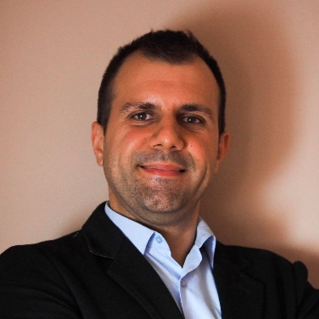
General Info
Name: Aleksandar Grbovic, 33 years old
Address: I live and work in Belgrade, Serbia

Employment History
March 2013- June 2014: Actavis Corporation
Medical representative, specialized in CVS and diabetes drugs, responsible for arranging appointments with doctors, pharmacists and hospital medical teams, pre-arranged appointments or regular 'cold' calling.

June 2014- present: Institute of Occupational medicine “Serbian Railways”
A medical doctor, licensed physician, practicing General Medicine, currently attending Radiology residency.
Institute was founded by Serbian Railways Company 130 years ago. Although we still provide specific medical services to rail personnel, Institute is nowadays a primary care medical facility responsible for more than 100.000 patients all over Serbia (approximately 50.000 patients in Belgrade branch).

March 2017- present: Freelance medical writer
For more than a year, I have been working as a freelance medical writer as well. Most of my articles are for lay people (by September 2018 I wrote 250 articles). As a medical writer, I have only one goal in my mind- to bridge the gap between doctors and patients point of view by breaking down complex medical topics and presenting them in lay people language. Knowing that my writing might help someone out there connect the dots is what keeps me motivated.
Currently, I work on a project of preparing educational materials for the Internal Medicine board exams in the US as well as for the USMLE step 1 and 2.
Education
2004- 2012 Faculty of Medicine, Belgrade University of Belgrade (12 semesters+ 1 year internship)
2016- Radiology residency program
Personal achievements
Lost 50lbs- twice (learned about yo-yo effect the hard way).
Hobbies
Photography, watercolor, guitar

